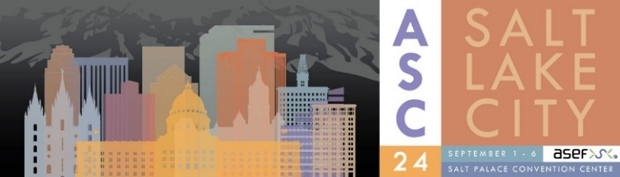
ONSITE
REGISTRATION FORM

Contact Information

First/Given Name: |  | Middle Name: |  |  | Last/Surname:
Title: |  |  | Affiliation:
Mailing Address:
City: | State/Province: |  |  | Zip/Postal Code: |  | Country:
Phone:  (If outside the US or Canada, please include country and city code as applies) |  |  |  | Fax:
Email: |  |  |  | Alternative Email:

General Registration Questions

Is this your first Applied Superconductivity Conference? Yes No
Gender: Female Male Transgender Female Transgender Male Gender Variant/Non-Conforming
Prefer not to say Other If Other, please describe:
Nationality:
Field: Academic National Lab Industry Retired Other If Other, please describe:
I obtained my first academic professional degree bachelor MSc or equivalent:
Less than 15 years ago More than 15 years ago Other
I authorize ASC 2024 to include my contact details in the attendee list that may be posted as a password protected PDF on the ASC 2024 website post conference.
Yes, you may share my contact information Name and Company/Institution Only
Do not include my name or contact information
I authorize ASC 2024 to include my contact information in the shared email distribution list. The list will be shared with other conferences or events with similar topics (e.g. EUCAS, MT, CEC/ICMC, IEEE CSC). If you opt-out, you will still receive emails specific to ASC Conferences.
Yes, you may share my email address Do not share my email address
Please read and acknowledge below:
I have read and acknowledge the ASC 2024 Code of Conduct
https://www.appliedsuperconductivity.org/asc2024/asc-code-of-conduct

I have read and acknowledge the ASC 2024 Terms and Conditions
https://www.appliedsuperconductivity.org/asc2024/asc-code-of-conduct

I have read and acknowledge the Applied Superconductivity Educational Foundation (ASEF) Privacy Policy.
https://www.appliedsuperconductivity.org/asc2024/privacy-policy
If you have dietary needs, please enter here:
Registration Options & Fees

Registration Fees - All amounts are listed in U.S. Dollars  Includes Technical Sessions, Exhibits, Welcome & Exhibitor Reception, Celebration Event, coffee breaks, one manuscript submission and a digital copy of the conference transactions published with IEEE Transactions on Applied Superconductivity available post-conference. | Onsite Fee | Total
Full Conference Attendee | $1450 | $
Student Participant - Not available to Post-Doctoral Fellows. | $725 | $
Retiree Participant | $725 | $

Day Pass Fees – Manuscript submission not included in Day Pass Registrations | 1 Day | 2 Days | Total
Day Pass / Technical Sessions  Includes technical session, exhibits and coffee break(s) on the selected day(s) only. You must select the day(s) you wish to attend in advance. Please select: Mon Tues Wed Thu Fri (half day) | $400 | $800 | $
Day Pass / Exhibits Only  Includes exhibits and coffee breaks on selected day(s) only. You must select the day(s) you wish to attend in advance. Please select: Mon (half day) Tues Wed Thu (half day) | $275 | $550 | $

Social Events - Extra Tickets for guests or Day Pass registrations | # of Tkts | Onsite Fee | Total
Welcome & Exhibitor Reception - Mon., Sep. 2 |  | $75 | $
Celebration Event - Thurs., Sep. 5 |  | $85 | $

ASC Short Courses – Sunday, September 1, 2024, 8:30AM - 5:00PM at the Salt Palace Convention Center | Non-Student Onsite | Student  Onsite | Total
Design of Superconducting Magnets for Particle Accelerators and Detectors | $475 | $350 | $
High Temperature Superconductors: From the Materials to Magnet Technology | $475 | $350 | $
Superconducting Power Devices and Cryogen-Free HTS Magnets | $475 | $350 | $
Superconducting Electronics | $475 | $350 | $
Superconducting Magnet Testing | $475 | $350 | $

Optional Items | # of Tkts | Fee | Total
4.2K Fun Run – Wed., Sept 4, 6:00AM |  | $30 | $
Additional Manuscript Submission – Enter Presentation ID here: |  | $440 | $

Payment Details

Total Payment Amount: US $

Please select from one of the following payment options:

Check Number: Cash Credit Card (will be processed onsite)
Checks must be in U.S. dollars, drawn on a U.S. bank, payable to “Applied
Superconductivity Educational Foundation.”. A $20 administrative fee will
be applied for all returned checks.

If you have a DISCOUNT CODE, please enter it here:

For Staff Use Only

Payment Authorization Number here: __________________________________

